Lab 04 report
Student: Ruslan Sabirov
Group: BS17-02

Task 1
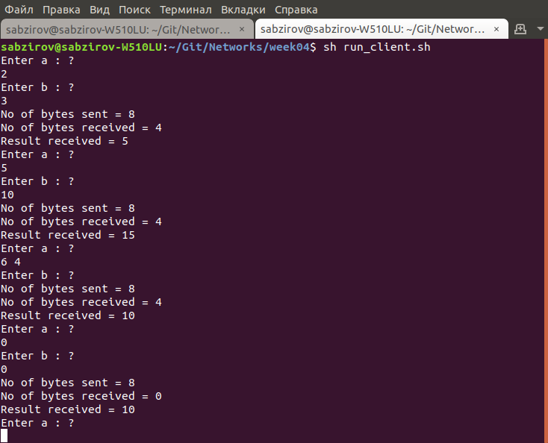Illustration 1: Client
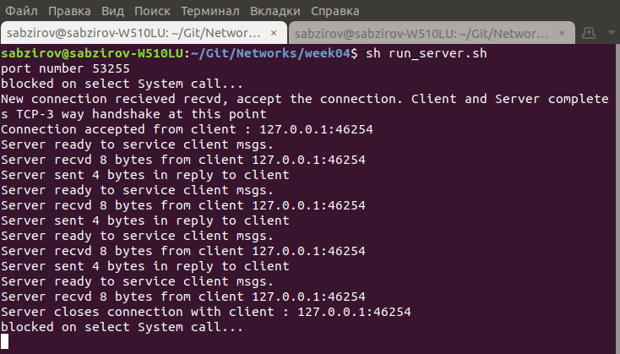Illustration 2: Server

Task 2
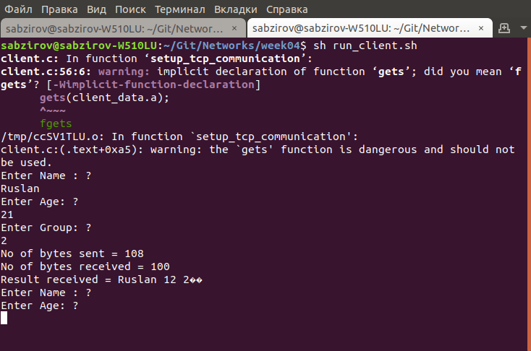Illustration 3: Client
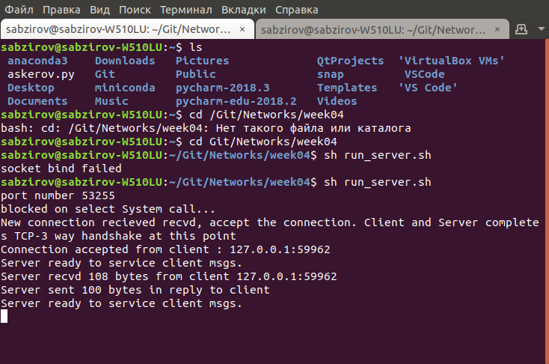Illustration 4: Server

Task 3
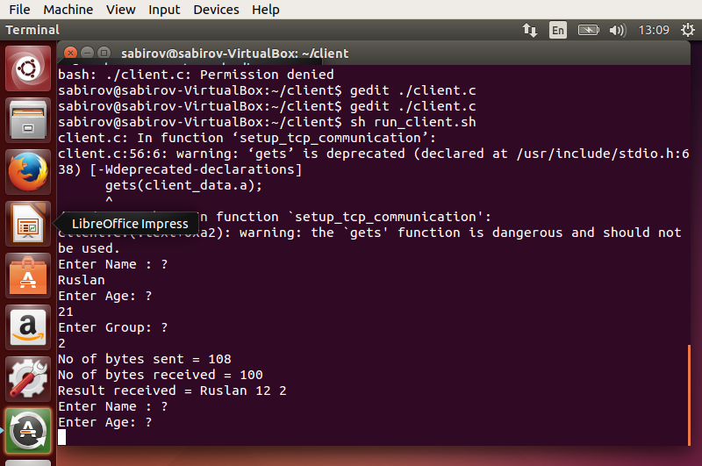Illustration 5: VM0 (client)
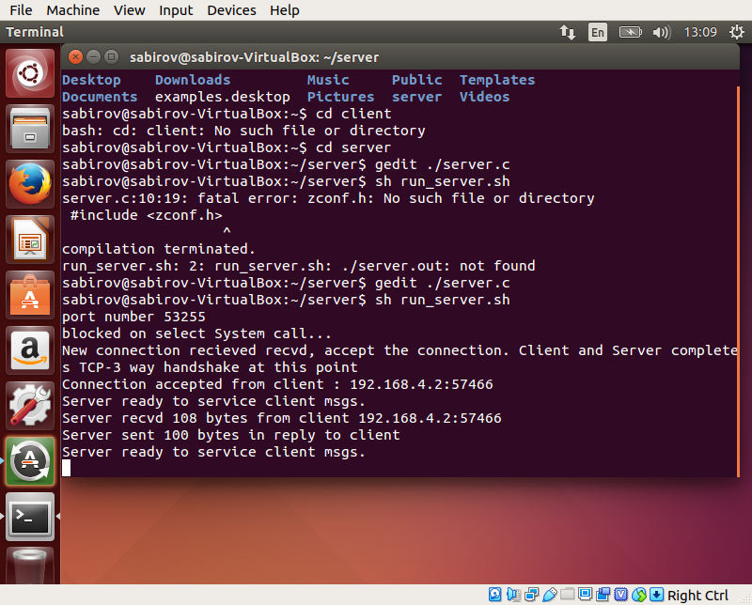Illustration 6: VM2 (server)

